CS Unplugged website

SDA PROJECT

# **BEHAVORIAL PATTERNS**

# Observer Pattern

UML

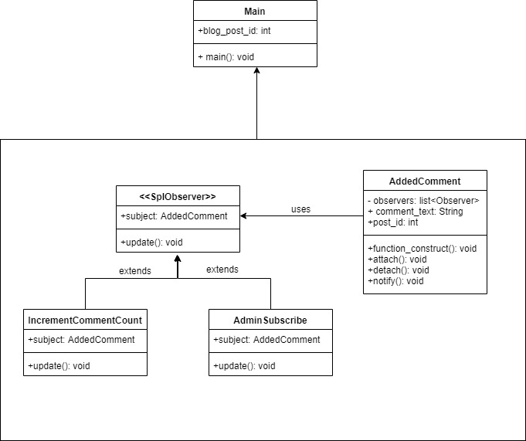

Explanation

Through observer pattern, the admin is notified each time the user makes a comment since it acts as a subscriber that extends the SplObserver abstract class. The AddedComment class is a context class which uses this abstract class to notify the admin. Each time a comment is made, the IncrementCommentCount class is also notified and so it increases a value in the counter.

# State Pattern

UML

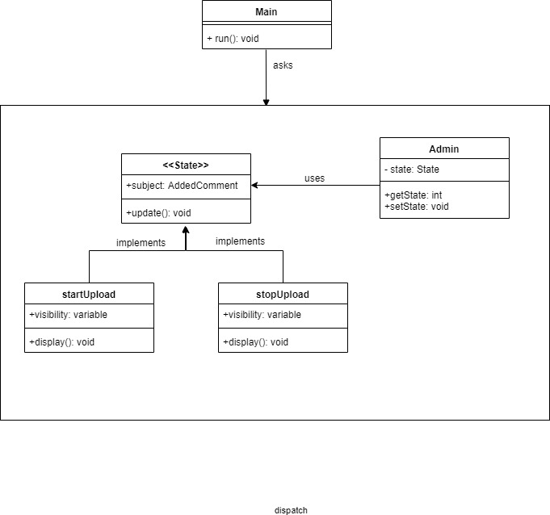

Explanation

Through this pattern, we set the states of the various divs of the HTML page by uploading a video. In short, while the video is uploading, the state of the HTML page will be startUpload. When the uploading will stop, the state of the page will be stopUpload.

# **STRUCTURAL PATTERNS**

# Proxy Pattern

UML

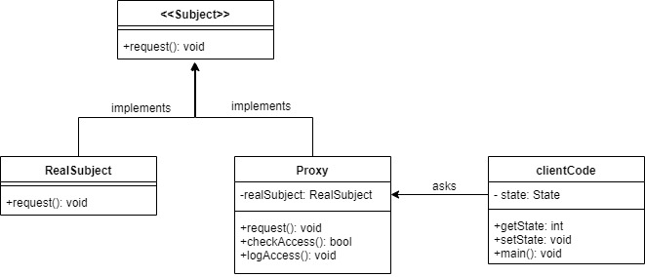

# **CREATIONAL PATTERNS**

# Singleton Pattern

UML

